**SUPER ADMIN USER MANUAL**

**LOGIN PAGE**

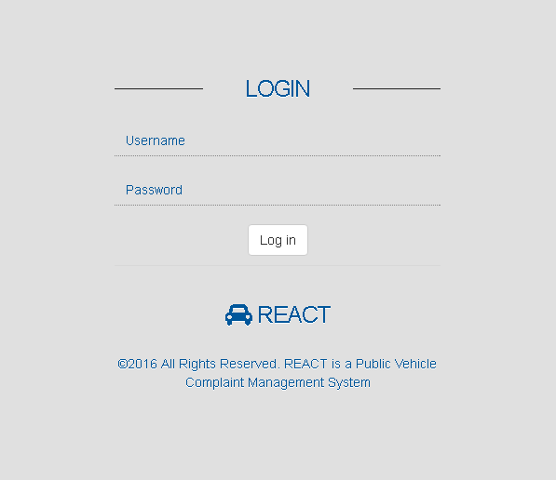

Username: admin

Password: admin

**DASHBOARD**

3

5

2

4

1

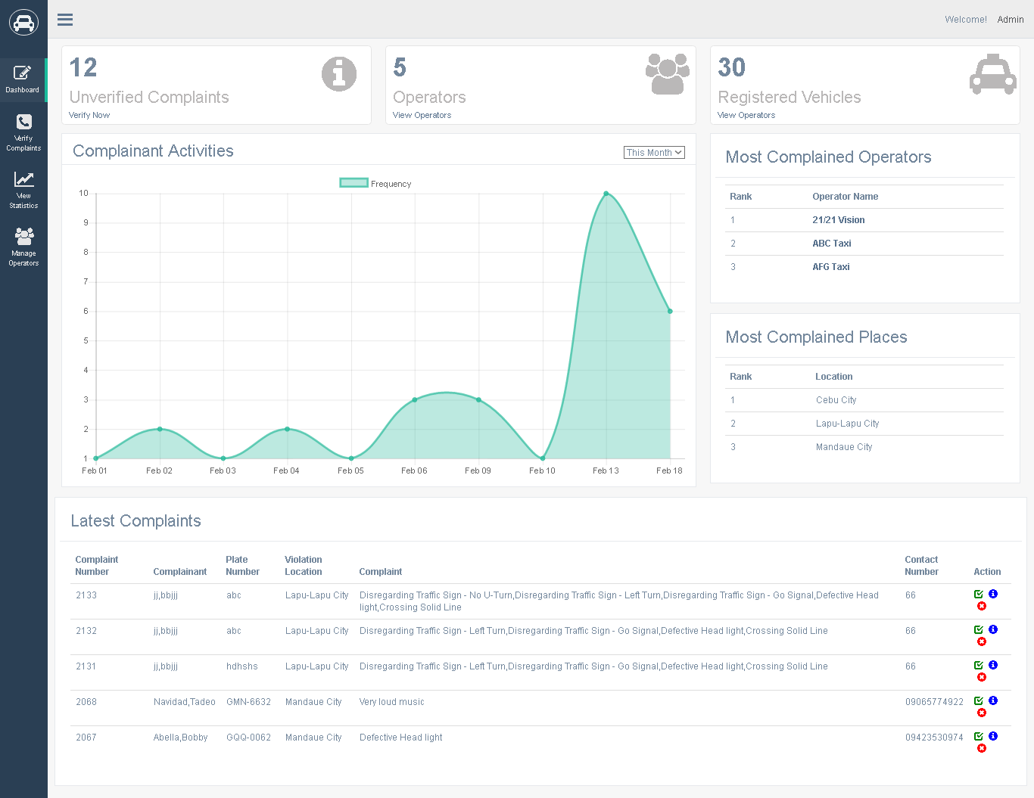

10

9

8

7

6

1. Displays unverified complaints of vehicles without operators, click to manage unverified complaints.

2. Displays all registered operators in the system, click to manage operators.

3. Displays all registered vehicles of operators.

4. Displays graphical complaint frequency by month, week and day.

5. Displays the most complained public vehicle operators.

6. Displays the locations with the most public vehicle complaints.

7. Displays the latest complaints.

8. Click to verify complaint.

9. Click to delete complaint.

10. Click to view complaint information.

**SIDE NAVIGATION PANEL**

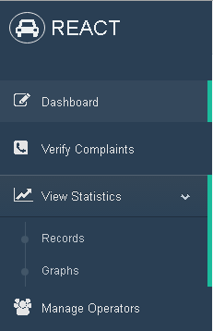

1

2

3

4

5

6

1. Dashboard Tab – Click to display dash board page (default).

2. Verify Complaints Tab – Click to displays verify complaints page.

3. View Statistics Tab – Click to Show the drop-down tabs: Records and Graphs tab.

4. Records tab – Click to display complaint records in detailed statistical interpretation.

5. Graphs tab – Click to displays detailed statistical graph representation of complaints.

6. Manage Operators – Click to displays manage operators page to manage all existing operators.

**VERIFY COMPLAINTS**

1

2

5

4

3

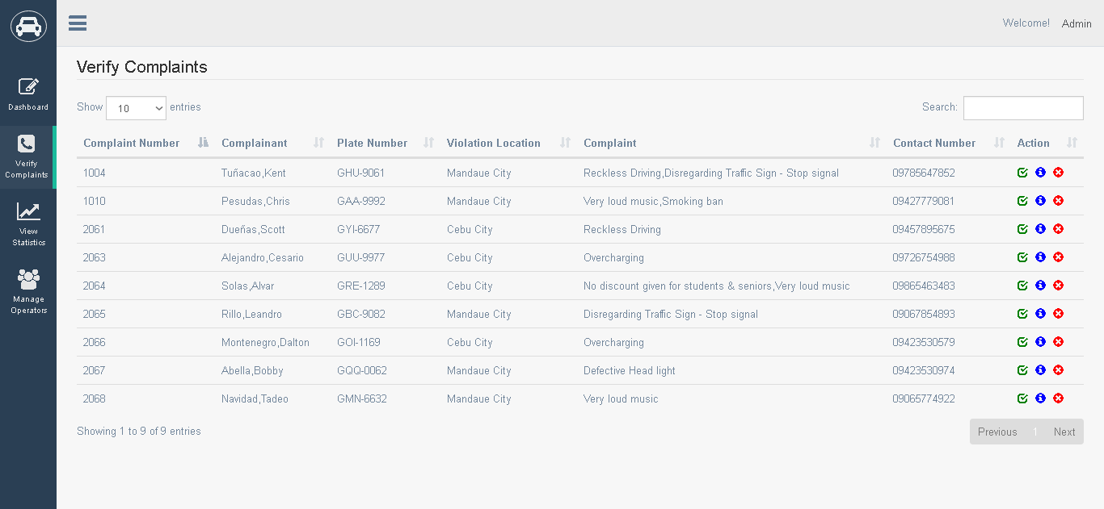

7

6

1. Click to choose desired number of entries

2. Type in to search complaint data

3. Click to verify complaint.

4. Click to display complaint information.

5. Click to delete unverified complaint.

6. Click to go to previous page..

7. Click to go to next table page.

**COMPLAINT DETAILS**

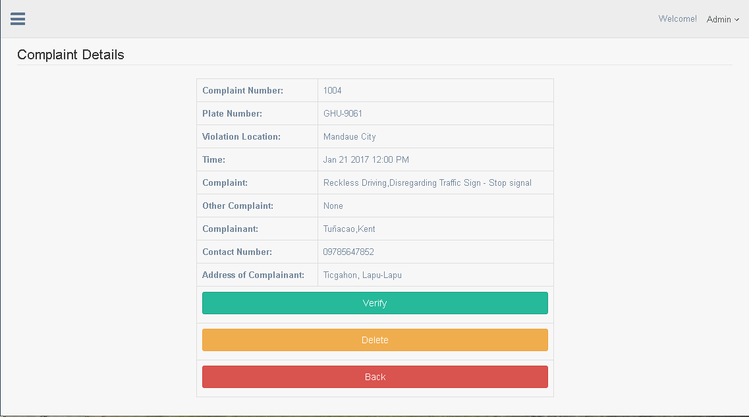

3

2

1

1. Click to verify unverified complaint.

2. Click to delete unverified complaint.

3. Click to return to previous page (Verify Complaints page).

**VIEW STATISTICS: RECORDS**

4

3

2

1

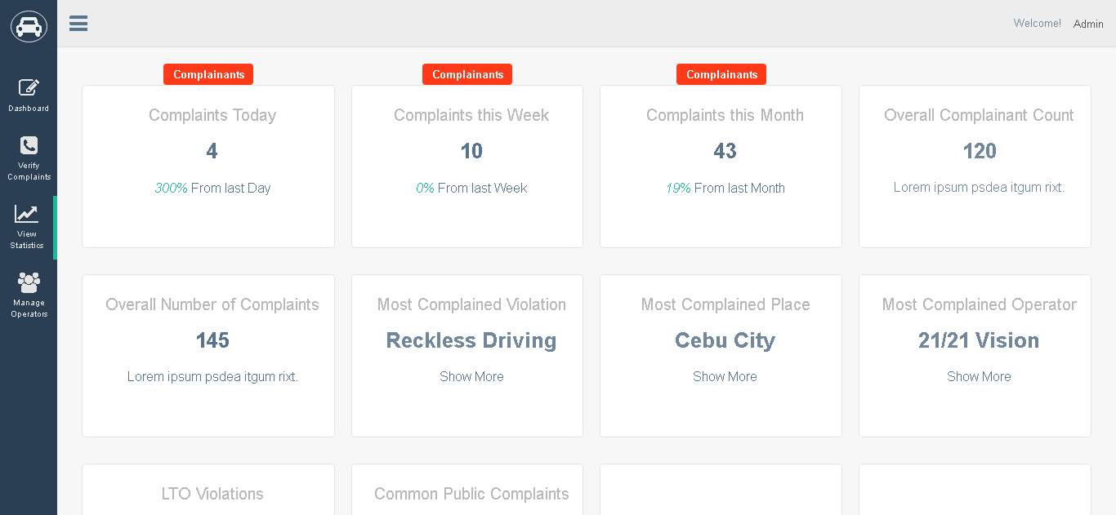

8

7

6

5

1. Click label to display number of complaints/complainants today.

2. Click label to display number of complaints/complainants this week.

3. Click label to display number of complaints/complainants this month.

4. Displays the total number of complainants.

5. Displays the total number of complaints received.

6. Displays the most complained Violation.

7. Displays the most complained city location.

8. Displays the most complained public vehicle operator.

**VIEW STATISTICS: GRAPHS**

4

3

2

1

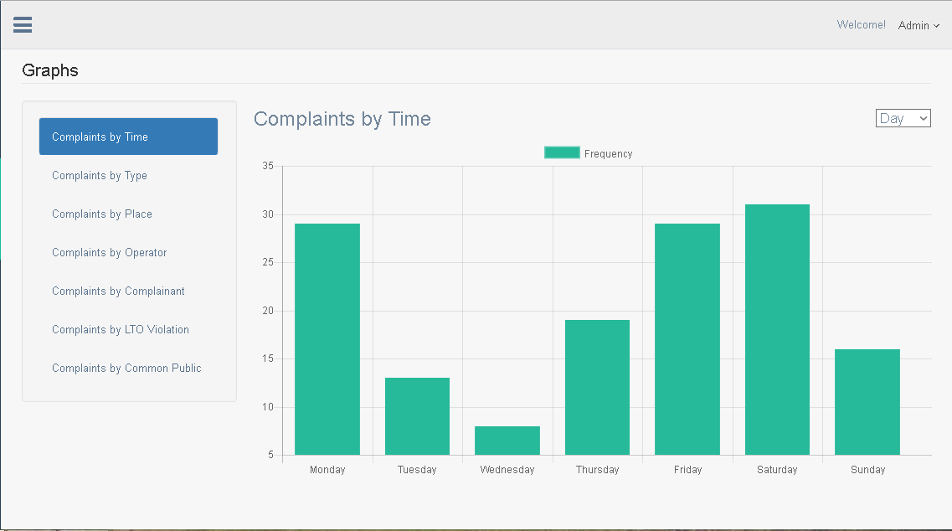

8

7

6

5

1. Click to show complaints by time graph (default)

2. Click to show complaints by type graph.

3. Click to show complaints by place graph.

4. Click to show complaints by operator graph.

5. Click to show complaints by complainant graph.

6. Click to show complaints by LTO violation graph.

7. Click to show complaints by common public violations graph.

8. Click to manipulate graph by day, hour and month.

**MANAGE OPERATORS**

4

5

3

2

1

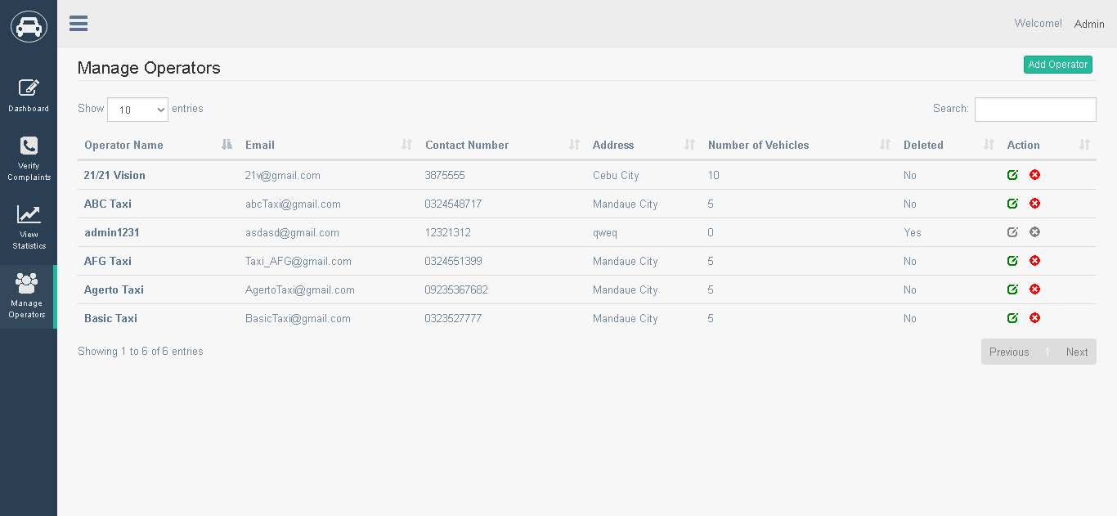

7

6

1. Click to choose desired number of entries.

2. Click to add new operator.

3. Type to search desired operator data.

4. Click to edit operator.

5. Click to delete operator.

6. Click to go to previous table page.

7. Click to go to next table page.**EDIT OPERATOR**

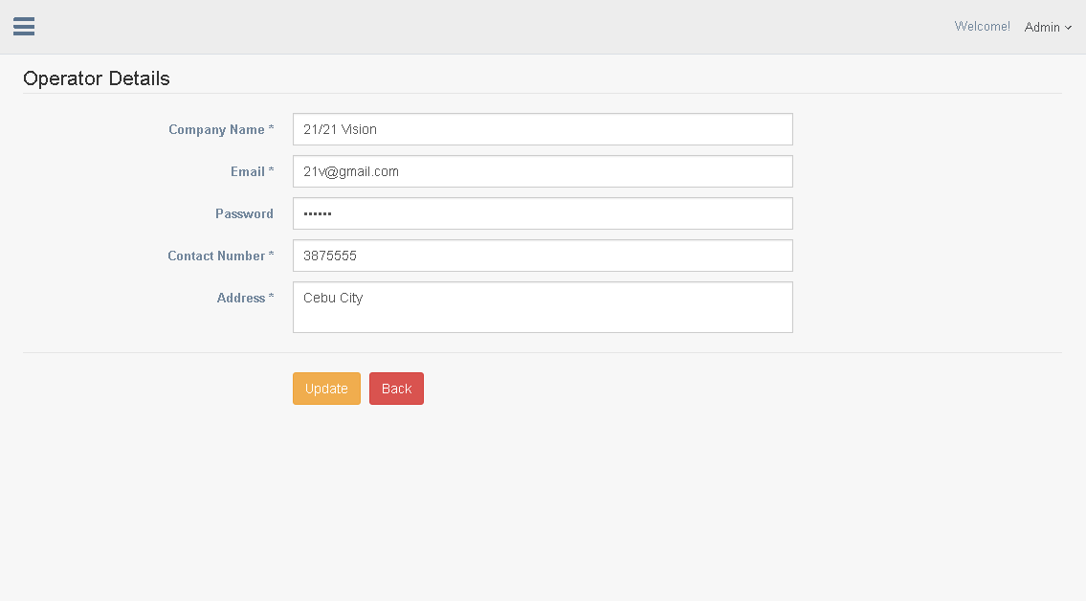

2

1

1. Click to update operator details.

2. Click to go back to previous page. (Manage operators)

**OPERATOR USER MANUAL**

**LOGIN PAGE**



To obtain an operator account, approach admin to be registered in the system.

**DASHBOARD**

7

3

2

1

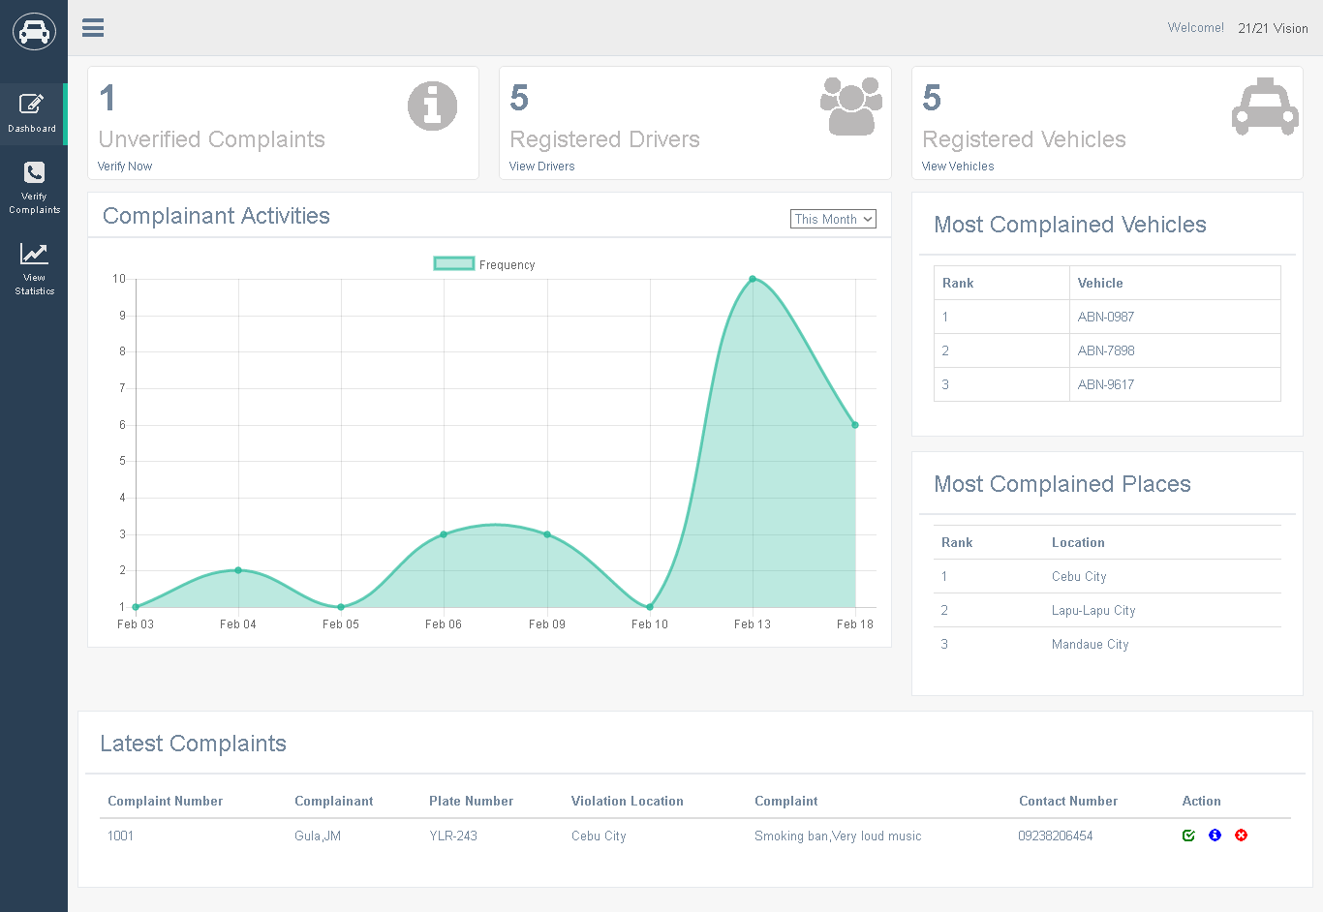

6

5

4

1. Displays unverified complaints.
2. Displays number of registered drivers..
3. Displays number of registered vehicles
4. Displays complaint activities frequency by, can be filtered by yesterday, today, this week, last week, this month and last month.
5. Displays latest complaints.
6. Displays most complained places.
7. Displays most complained vehicles.

**SIDE PANEL NAVIGATION**

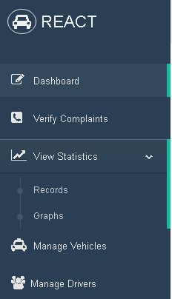

4

3

7

6

5

22

1

1. Click to display dashboard (default)
2. Click to display verify complaints page.
3. Click to show drop-down statistics tabs: records and graphs.
4. Click to display records statistics page.
5. Click to display graphs statistic page.
6. Click to display manage vehicles page.
7. Click to display manage drivers page.

**VERIFY COMPLAINTS**

5

4

3

2

1

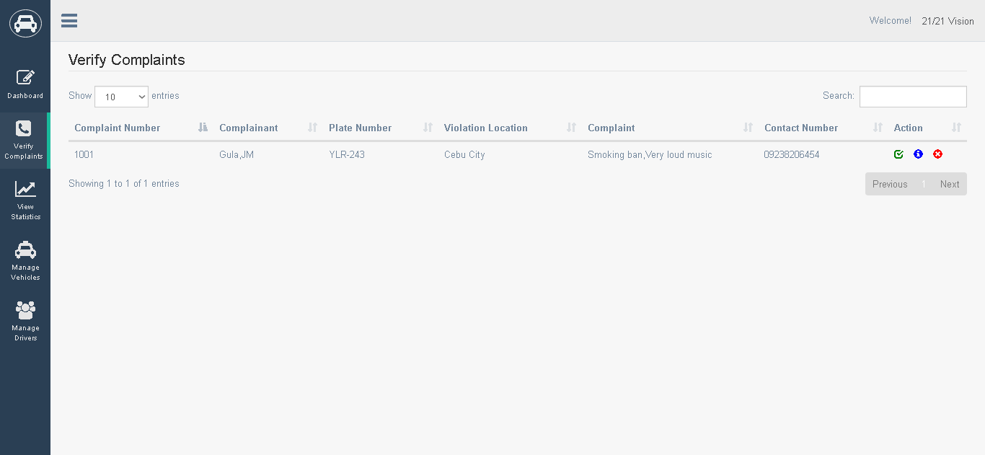

7

6

1. Displays number of desired entries to be shown below.
2. Type in to search complaint data.
3. Click to verify complaint.
4. Click to show complaint information details.
5. Click to remove complaint.
6. Click to go to previous table page.
7. Click to go to next table page.

**COMPLAINT DETAILS**

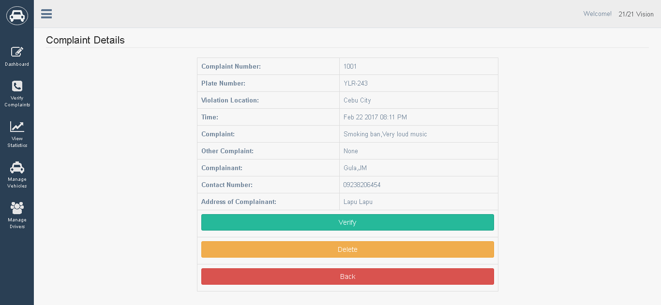

3

2

1

1. Click to verify complaint.
2. Click to delete complaint.
3. Click to redirect to previous page.

**VIEW STATISTICS: RECORDS**

4

3

2

1

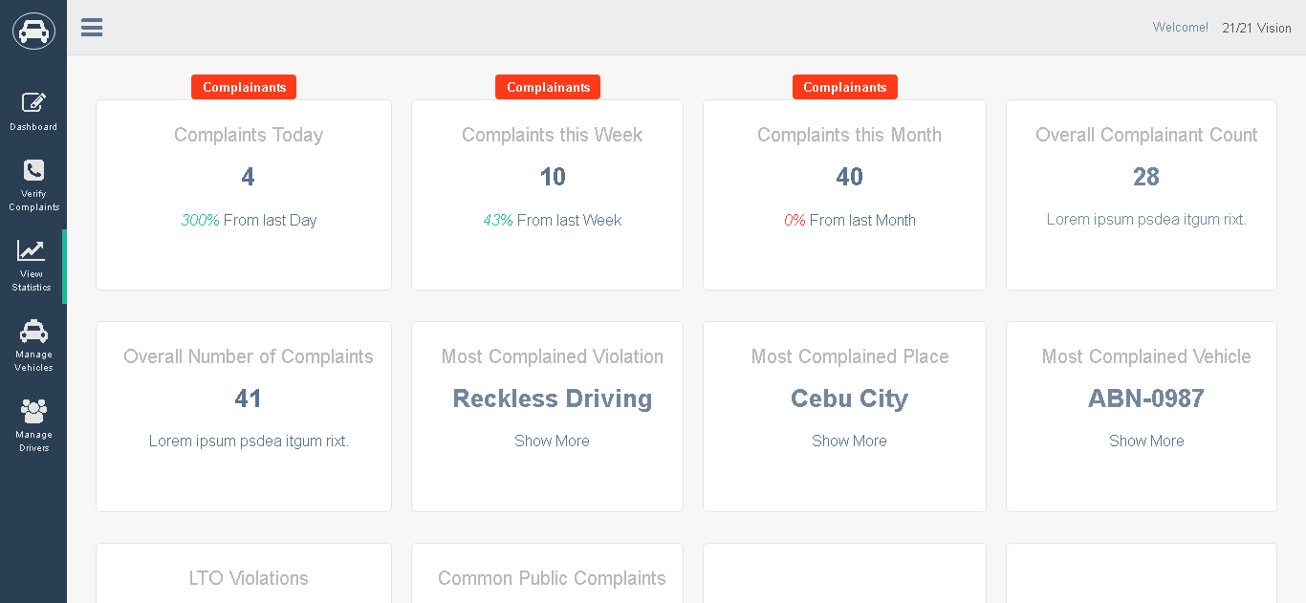

8

7

6

5

1. Click label to display number of complaints/complainants today.

2. Click label to display number of complaints/complainants this week.

3. Click label to display number of complaints/complainants this month.

4. Displays the total number of complainants.

5. Displays the total number of complaints received.

6. Displays the most complained Violation.

7. Displays the most complained city location.

8. Displays the most complained public vehicle operator.

**VIEW STATISTICS: GRAPHS**

4

3

2

1

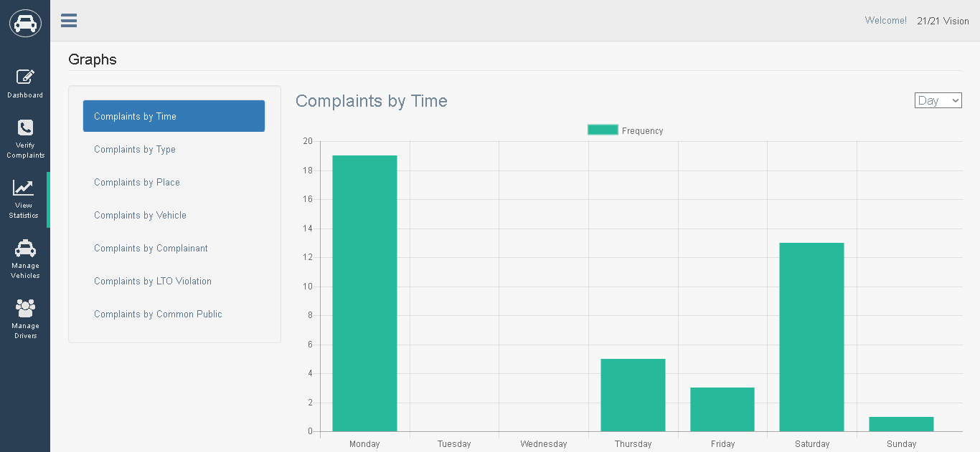

8

7

6

5

1. Click to display complaints by time graph (default).
2. Click to display complaints by type graph.
3. Click to display complaints by place graph.
4. Click to change filter by day, hour or month.
5. Click to display complaints by vehicle graph.
6. Click to display complaints by complainant graph.
7. Click to display complaints by LTO violation graph.
8. Click to display complaints by common public violations graph.

**MANAGE VEHICLES**

6

5

4

3

2

1

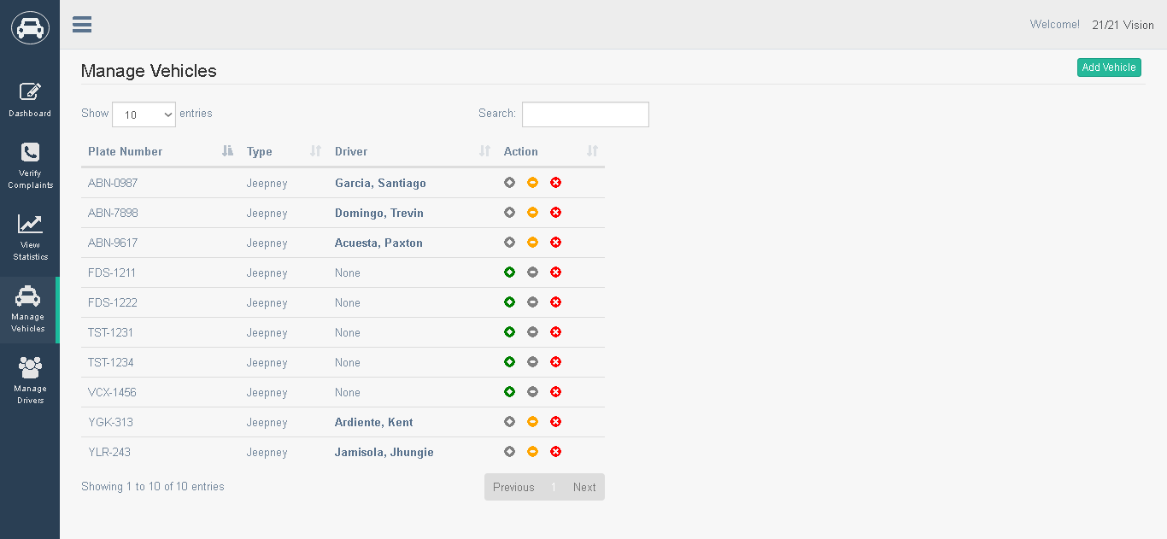

8

7

1. Click to show desired number of vehicle entries.
2. Click to assign driver to vehicle.
3. Click to unassign driver to vehicle.
4. Click to remove vehicle.
5. Click to search data inside table.
6. Click to add vehicle.
7. Click to go to previous table page.
8. Click to go to next table page.

**ADD VEHICLE**

2

1

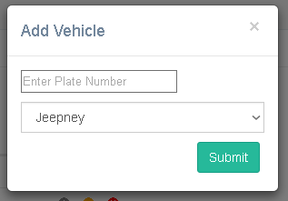

4

3

1. Type in vehicle plate number.
2. Click to cancel operation,
3. Click to choose vehicle type between jeepney or taxi.
4. Click to submit add vehicle information.

**MANAGE DRIVERS**

3

4

5

2

1

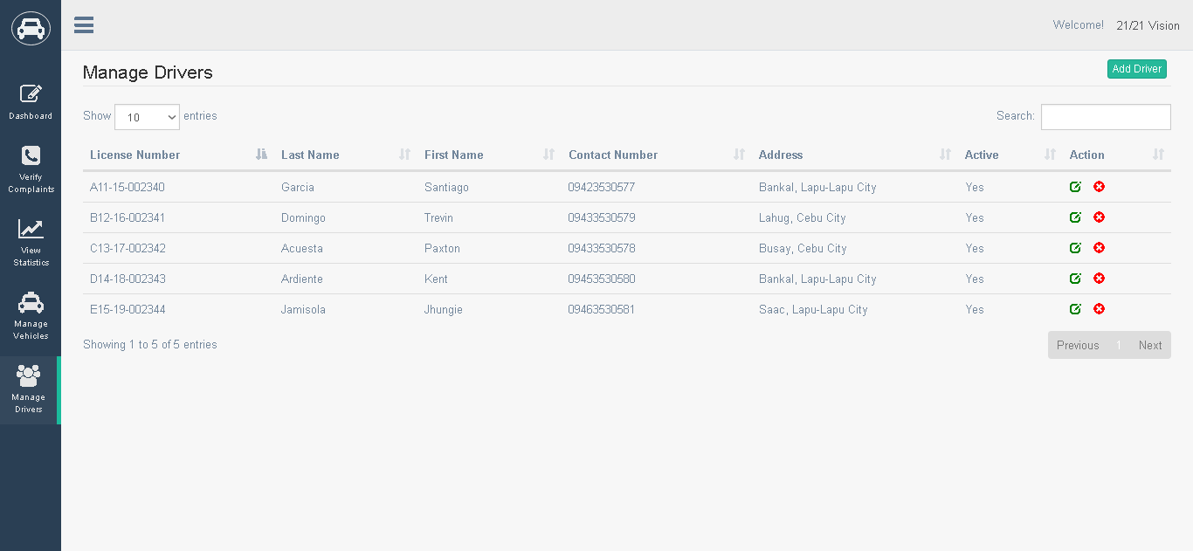

6

7

1. Click to choose desired number of driver entries.
2. Click to edit driver information.
3. Click to remove driver.
4. Type in to search driver information.
5. Click to add driver.
6. Click to go to previous table page.
7. Click to go to next table page.

**ADD DRIVER**

5

4

3

2

1

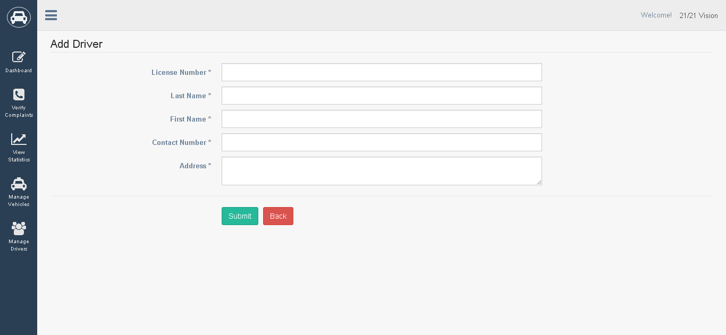

6

7

1. Input driver license.
2. Input driver last name.
3. Input driver last name
4. Input driver contact number.
5. Input driver address.
6. Click to submit add driver information.
7. Click to go back previous page.

**DRIVER RECORDS**

1

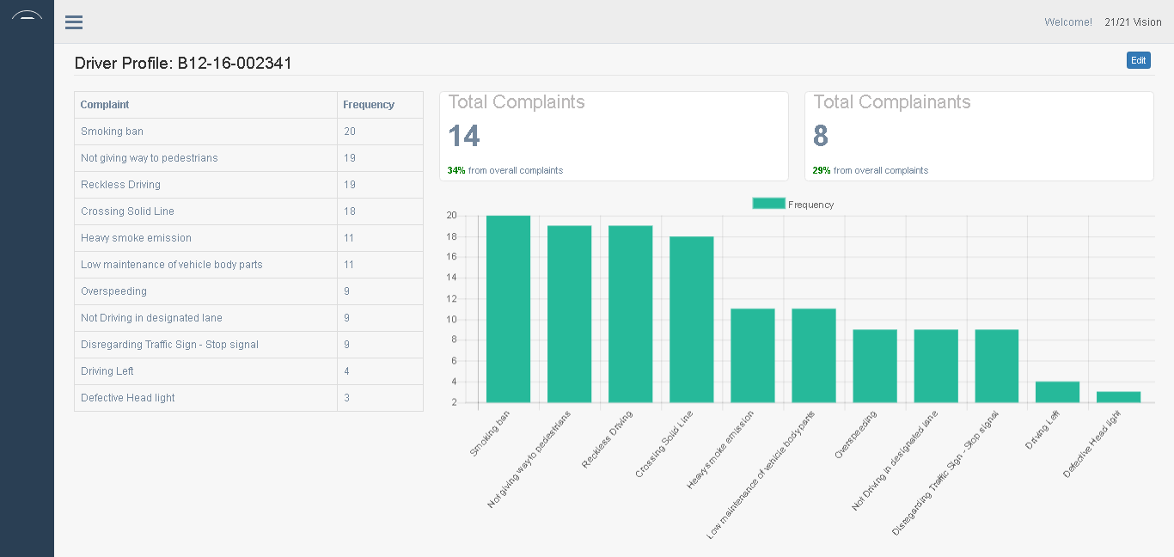

1. Click to edit driver information.

**EDIT DRIVER**

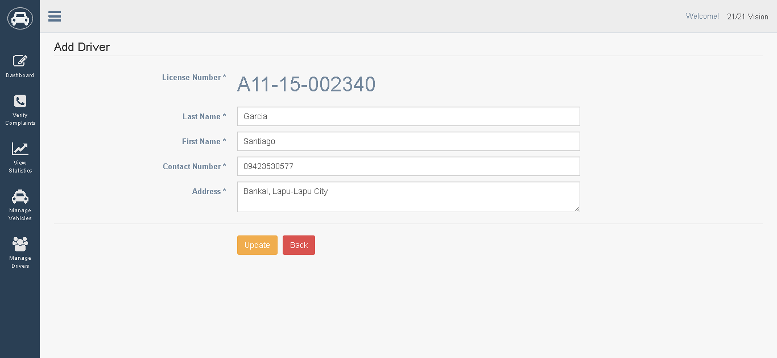

2

1

1. Click to update driver information.
2. Click to discard changes and return to previous page.